INDIAN SCHOOL AL WADI AL KABIR
TERM 1: Chapter 3- Social Institutions: Continuity & change (GRADE XII)
NOTES AND Q&A

TEXTBOOK QUESTIONS:

- What is the role of the ideas of separation and hierarchy in the caste system?
Ans. The caste system can be understood as the combination of two sets of principles, one based on difference and separation and the other on wholism and hierarchy.
Each caste is different and strictly separated from every other caste on the basis of restrictions. These restrictions are related to marriage, food sharing and social interaction to occupation.
Different and separated castes do not have an individual existence. They exist in relation to a larger whole. This societal whole or system is a hierarchical rather than egalitarian system.
Each individual caste follows an ordered rank—a particular position in a ladder like arrangement going from highest to lowest.
The hierarchical ordering of castes is based on the distinction between purity and pollution.
Castes that are considered ritually pure have high status, while those considered less pure or impure have low status.
Historians believe that those who were defeated in wars were often assigned low caste status.
Castes are not only unequal in ritual terms. They are complementary and non-competing groups. It means each caste has its own place in the system which cannot be taken by any other caste.
Caste is also linked with occupation, the system functions as a social division of labour. It allows no mobility. This idea of separation and hierarchy has inculcated discrimination, inequality and prejudices in Indian society.

- What are some of the rules that the caste system imposes?
Ans. The most commonly cited rules that the caste system has imposed are as follows:
•Caste is determined by birth-a child inherits the caste of its parents. One can never change one’s caste, leave it, or choose not to join it. Caste is never a matter of choice.
•Membership in a caste involves strict rules about marriage. Caste groups are “endogamous” i.e. marriage is restricted to members of the group.
•Members of a particular caste have to follow rules about food and food sharing.
•An individual born into a caste could only practice the occupation associated with that caste, so that occupations were hereditary.
•Caste involves hierarchy of rank and status. Every person has a caste. Every caste has a caste. Every caste has a specified place in the hierarchy of all castes.
•Castes involve sub-division within themselves. Sometimes sub-castes may also have sub-caste i.e. segmental organization.

- What changes did colonialism bring about in the caste system?
Ans. The institution of caste underwent major changes during the colonial period.
Present status of caste in India is more a product of colonialism than of ancient Indian tradition.
The British administrators tried to understand the complexities of caste in an effort to learn how to govern the country efficiently.
The most important official effort to collect information on caste was through census. It began in 1860s.
The 1901 census under the direction of Herbert Risley was particularly important as it sought to collect information on the social hierarchy of caste i.e. the social order of precedence in particular regions, as to the position of each caste in the rank order.
The counting of caste and to officially recording of caste made this institution of caste identity became more rigid in India.
The land revenue settlements and laws gave legal recognition to the caste based rights of the upper caste.
Large scale irrigation schemes were accompanied by efforts to settle population there, and these also had caste dimension.
So colonialism brought about major changes in the institution of caste. In short, the Britishers took initiative in following areas:
(i) Census-to make sure of number and sizes of the castes and sub-castes.
(ii) To understand the values, beliefs and customs of different sections of society.
(iii) Land settlement.

4.In what sense has caste become relatively ‘invisible’ for the urban upper castes?
Ans. The changes in the caste system benefited the most were urban middle and upper class. Caste status ensured these groups the necessary economic and educational resources and they took full advantage of the opportunities offered by rapid development. Particularly the upper caste elite were able to benefit from subsidized public education, especially professional education in science, technology, medicine and management. They were also able to take advantages of the expansion of state sector jobs in the early decades after independence. Because of this earlier load over the rest of the society in terms of education ensured a privileged status.
For the so-called SC and ST and backward castes this change became detrimental. For these the caste became all too visible. They had not inherited educational and social capital and they had to compete with already established upper caste group. They cannot afford to abandon their caste identity. They continue to suffer from discrimination of various kinds.

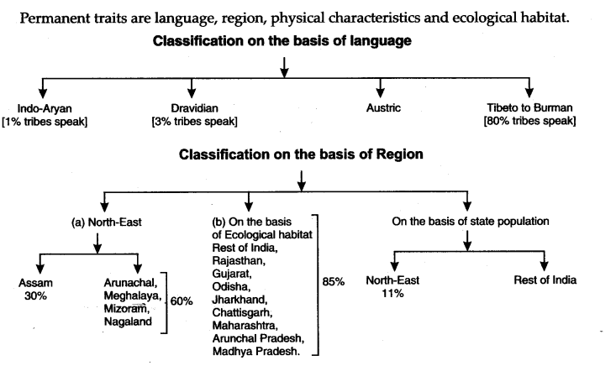
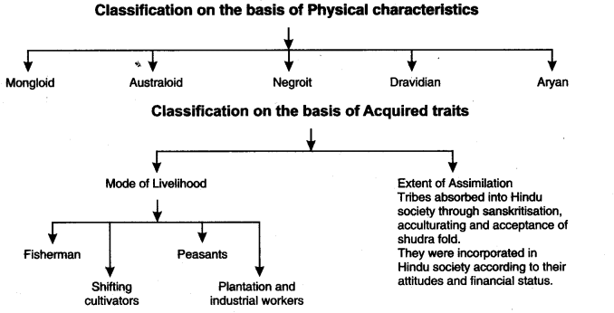
6.What evidence would you offer against the view that ‘tribes are primitive communities living isolated lives untouched by civilization?
Ans. There is no reason to believe that tribes are out of contact with the rest of world or have always been the oppressed section of the society. This can be said because of the following reasons:
1.Gond Kingdoms in central India such as that of Garha Mandla or Chanda.
2.Many of the Rajput Kingdoms of central and western India emerged through a process of stratification among adivasi communities themselves.
3.Adivasi often exercised dominance over the plains people through their capacity to raid them and through their services as local militias.
4.They also occupied a special trade niche, trading forest produce, salts and elephants.
Evidences substantiating tribes as primitive communities:
1.Tribes have not a state or political form of the normal kind.
2.They have no written rules on religion.
3.They are neither Hindus nor peasants.
4.Primarily they are engaged in activities like food gathering, fishing, hunting, agriculture etc.
5.The habitat of tribes is in dense forests and mountainous regions.
7. What are the factors behind the assertion of tribal identities today?
Ans. • Forced incorporation or tribal communities has had a negative impact on tribal cultures and, society as much as its economy.
•Tribal identities are today formed by interactional process.
•Because this interactional process has not been in favour of the tribes, many tribal identities are based on ideas of resistance and opposition to the overwhelming force of the non-tribal world.
•The positive impact of success such as the achievement of statehood for Jharkhand and Chhattisgarh, is marred by continuous problems. Many citizens of the northeastern states have been living under special laws that limit their civil liberties. The vicious circle of armed rebellions provoking state repression which in turn fuels further rebellions has taken a heavy toll on the culture, economy, and society of these north-eastern states.
•Gradual emergence of an educated middle class in conjunction with the policy of reservation is creating an urbanised professional class. As tribal societies get more and more differentiated i.e. developed class and other division within themselves, current bases grow for the assertion of tribal identity.
•These issues are categorised to control over vital economic resources like land and specially forests, and issues relating to matters of ethnic-cultural identity.
•Due to vision within the tribes, the reason for asserting tribal identity may be different for different group of tribals.
8. What are some of the different forms that the family can take?
Ans. Family is a very important social institution. In either form i.e. nuclear or extended, it has post to perform. Lately, a lot of changes have come about in the structure for example, those people employed in the software industry have odd working to this, grandparents have shifted in as caregivers to young.
A family could be headed by a male or female; descent could be traced from the mother or the father. This structure and composition of the family is based on various factors ‘ such as economy, polity, culture and education.
The changes in the structure of family that we see today could be
(i)Same sex marriage
(ii)Love marriage
But history and contemporary times suggest that such changes are met with violent reactions.
Nuclear Family: It consists of one set of parents and their children.
Extended Family: It consisted of more than one couple and, often, more than two generations live together. The extended family is symptomatic of India.
Diverse forms of family (i) Matrilocal-patrilocal (based on residence)
(ii) Matrilineal and patrilineal (based on rules of inheritance)
(iii) Matriarchal and patriarchal (based on authority)
9. In what ways can changes in social structure lead to changes in the family structure?
Ans. The structure of family can be seen as social institution and also in its relationship to other social institution of society.
•The internal structure of the family is usually related to other structure of society i.e. political, economic, cultural, etc. Therefore, any significant change in behaviour pattern of members of family may change the nature of society for example working schedules of young parents in the software industry in India may lead to increasing number of grandparents moving in as caregivers to the young grandchildren.
•The composition of the family and its structure thereby changes. And these changes can be understood in relation to other changes in society.
•The family (the private sphere) is linked to the economic, political, cultural and educational (the public) spheres.
•Sometimes the changes in the families and corresponding changes in the society occur accidently e.g. due to war or riots people migrate in search of work or for security reasons.
•Sometimes these changes are purposefully brought about, e.g. due to independence and openness of ideas, people choosing their jobs, life partner and life style and such changes are very frequent in the Indian society.
10. Explain the difference between matriliny and matriarchy.
Ans. Matriliny.
•Societies of Meghalaya Khasi, Jaintia, Garo tribes and societies of Kerala, Nayyar family property inheritance goes from mother to daughter whereas control passes from maternal uncle to Nephew.
•It means a women inherits property from mother and passes on to her daughter while a man controls his sister’s property and passes on control to his sister’s son.
•This matriliny generates intense role conflict for men because they are in conflict between their responsibilities to their own house on the one hand and to their wife and children on the other-“Should I pay more attention to my family or my sister’s family.”
This role conflict is for woman also.
She possesses only token authority, men are the defacto powerholders. Despite matriliny men are the powerholders.
Matriarchy
•In such societies the women exercise authority and play dominant role.
•Practically it is only a theoretical concept as it never allows the women to have real power of dominance.
•Realistically it is not existed even in matrilineal families.

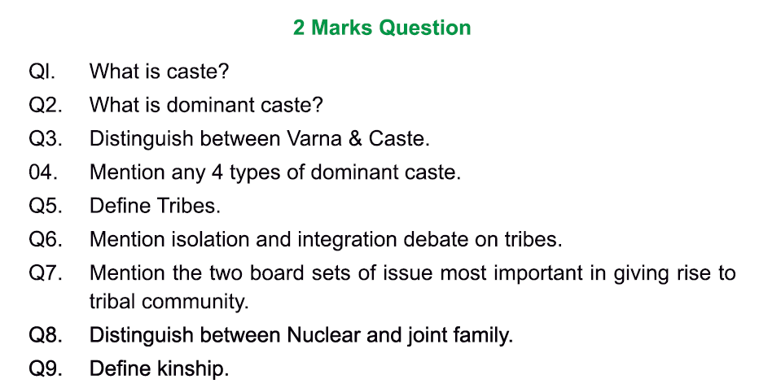
ANSWERS:
1. The term caste is derived from the Portuguese word ‘casta’ which means pure breed. In other words it also means a group/community of people. Caste is also called ‘jati’. Caste can also be described as a segmental division of stratification in society acquired by birth.
According to G.S Ghurye, “caste is a segmental division of society having a hierarchy of groups, professing a fixed occupation, having allied and religious disabilities and privileges with restrictions on marriage, feeding and social intercourse., It is an endogamous group determined by birth.
2. A dominant caste refers to a middle or upper caste with a large population and newly acquired land ownership rights. These are not from the Brahmins, Kshatriya or Vaishya varna but from intermediate castes.
3. Caste refers to the segmental division of stratification in society acquired by birth that got formalized in the post Vedic period. It is a fairly closed system which is very rigid and no social mobility is possible.
Varna literally refers to ‘colour’- a nationwide version of the caste system dividing society into four hierarchically ordered varnas or caste group named Brahmin, Kshatriya, Vaishya and shudra. It is an open system that originated in the Vedic period where social mobility was possible.
4.Yadavas from Bihar, Jats from Haryana, Maratha caste from Maharashtra, Reddys from Andhra Pradesh.
5. Tribe is a modern term, which refers to communities that are very old, being among the oldest inhabitants of the sub-continent. The tribal communities didn’t practice a religion with a written text, didn’t have state class divisions and they didn’t have caste and were neither Hindus nor peasants. The term tribe was used in the colonial era mainly for administrative convenience to refer to a very disparate set of communities.
6.
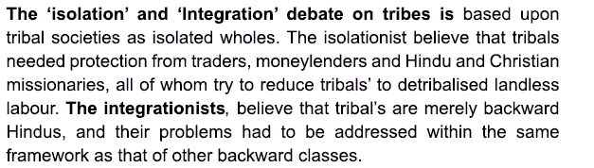
7. The two broad set of issues that were most important in giving rise to tribal communities in India are as follows:
8. JOINT FAMILY -
A family group that consists only of parents and their children is called a nuclear family. On the other hand, a family which extends beyond the nuclear family to include grandparents and sometimes other relatives also is called an extended family.
9. In common parlance, kinship is understood as part of culture which deals with notions of or ideas about relatedness or relationship through birth and marriage.
ADDITIONAL NOTES:
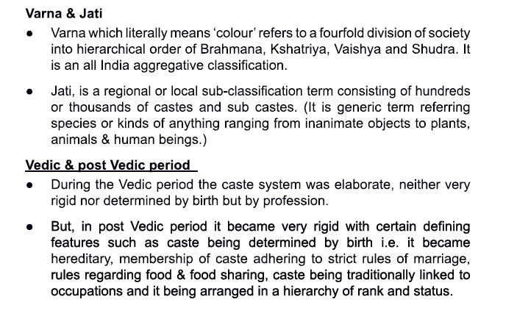
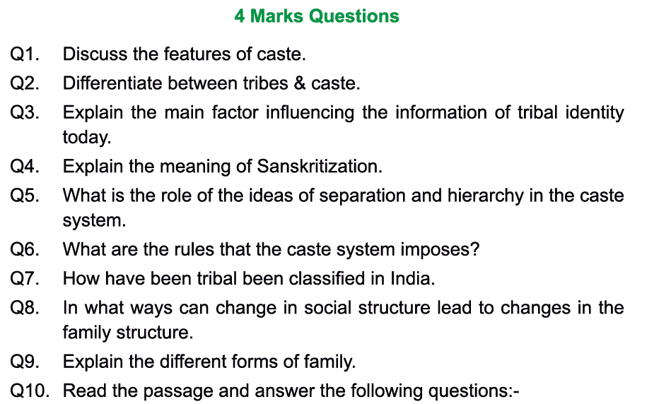
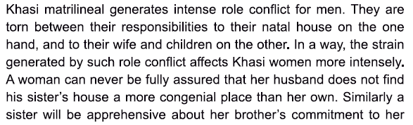
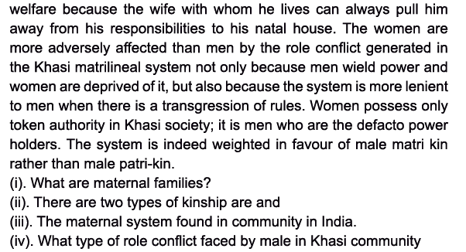

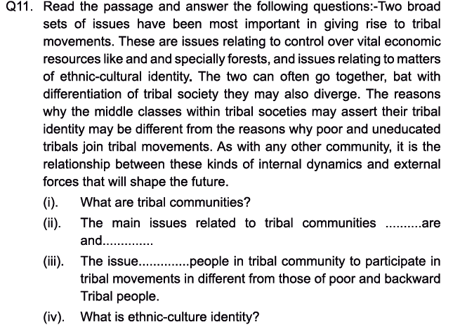

ANSWERS: 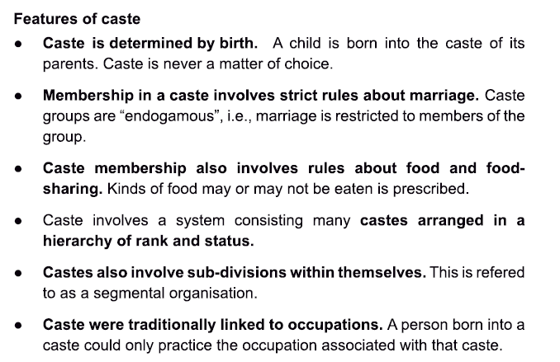
2. Difference between caste and tribe:
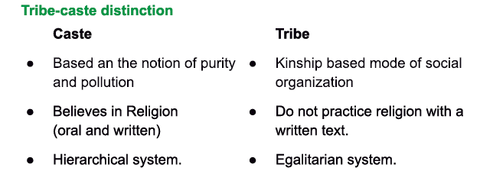
3.The main factor influencing the formation of tribal identity today:
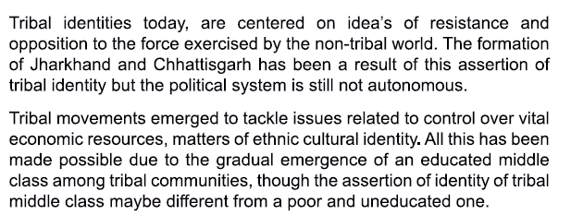
- Sanskritization refers to a process whereby members of a (usually middle or lower) caste attempt to raise their own social status by adopting a ritual, domestic and social practices of a caste of higher status. Although this phenomenon is an old one and predates Independence and even the colonial period, it has intensified in recent times. The patterns for emulation chosen were most often the brahmin or kshatriya castes: practices included adopting vegetarianism, wearing of sacred thread, performance of specific prayers and religious ceremonies and so on. Sanskritization usually accompanies or follows a rise in the economic status of the caste attempting it, though it may also occur independently.
Note: The remaining questions in this section have been answered earlier (as textbook questions)
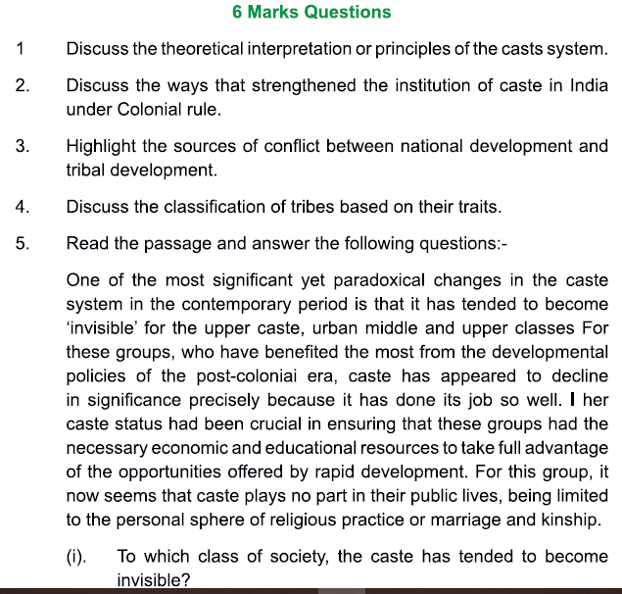

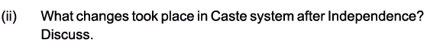
ANSWERS: